Aim:- Develop web page to demonstrate the auto post back using a list box to select and display items

Go to new project --> ASP.NetWeb Apllication(.net framework) -->Create project -->right click on project --> Add 🡪 web form

In design 🡪 right click 🡪 properties 🡪 AutoPostBAck change to True

Webform.aspx :-

<%@ Page Language="C#" AutoEventWireup="true" CodeBehind="WebForm1.aspx.cs" Inherits="firstawt.WebForm1" %>

<!DOCTYPE html>

<html xmlns="http://www.w3.org/1999/xhtml">

<head runat="server">

<title></title>

</head>

<body>

<form id="form1" runat="server">

<div>

<asp:ListBox ID="ListBox1" runat="server" AutoPostBack="True" OnSelectedIndexChanged="ListBox1_SelectedIndexChanged">

<asp:ListItem>Red</asp:ListItem>

<asp:ListItem>Green</asp:ListItem>

<asp:ListItem>Blue</asp:ListItem>

</asp:ListBox><br />

<asp:Label ID="Label1" runat="server" Text="Label"></asp:Label><br />

</div>

</form>

</body>

</html>

Webform1.aspx.cs :-

using System;

using System.Collections.Generic;

using System.Linq;

using System.Web;

using System.Web.UI;

using System.Web.UI.WebControls;

namespace firstawt

{

public partial class WebForm1 : System.Web.UI.Page

{

protected void Page_Load(object sender, EventArgs e)

{

}

protected void ListBox1_SelectedIndexChanged(object sender, EventArgs e)

{

if (ListBox1.SelectedItem != null)

{

Label1.Text = "You selected " + ListBox1.SelectedItem.ToString();

}

else {

Label1.Text = "Select any item from the list box";

}

}

}

}

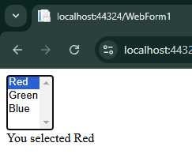 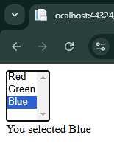 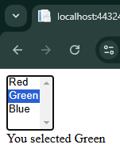

Parctical 2

Design a web form that take user input

WebForm.aspx:-

<%@ Page Language="C#" AutoEventWireup="true" CodeBehind="WebForm1.aspx.cs" Inherits="AWT_practical_2.WebForm1" %>

<!DOCTYPE html>

<html xmlns="http://www.w3.org/1999/xhtml">

<head runat="server">

<title></title>

</head>

<body>

<form id="form1" runat="server">

<div>

<asp:Label ID="Label1" runat="server" Text="User Name"></asp:Label>

<asp:TextBox ID="TextBox1" runat="server" OnTextChanged="TextBox1_TextChanged"></asp:TextBox><br />

<asp:Label ID="Label2" runat="server" Text="User Email"></asp:Label>

<asp:TextBox ID="TextBox2" runat="server" OnTextChanged="TextBox2_TextChanged"></asp:TextBox><br />

<asp:Label ID="Label3" runat="server" Text="User Feedback"></asp:Label>

<asp:TextBox ID="TextBox3" runat="server" OnTextChanged="TextBox3_TextChanged" Width="128px"></asp:TextBox><br />

<asp:Button ID="Button1" runat="server" Text="Submit" OnClick="Button1_Click" /><br />

<asp:Label ID="Label4" runat="server" Text="Label"></asp:Label><br />

<asp:Label ID="Label5" runat="server" Text="Label"></asp:Label><br />

<asp:Label ID="Label6" runat="server" Text="Label"></asp:Label><br />

</div>

</form>

</body>

</html>

WebForm1.aspx.cs:-

using System;

using System.Collections.Generic;

using System.Linq;

using System.Web;

using System.Web.UI;

using System.Web.UI.WebControls;

namespace AWT_practical_2

{

public partial class WebForm1 : System.Web.UI.Page

{

protected void Page_Load(object sender, EventArgs e)

{

}

protected void Button1_Click(object sender, EventArgs e)

{

Label4.Text = "Username : " + TextBox1.Text;

Label5.Text = "Email : " + TextBox2.Text;

Label6.Text = "Feedback : " + TextBox3.Text;

}

protected void TextBox1_TextChanged(object sender, EventArgs e)

{

}

protected void TextBox2_TextChanged(object sender, EventArgs e)

{

}

protected void TextBox3_TextChanged(object sender, EventArgs e)

{

}

}

}

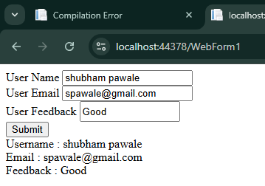

**Practiccal No 3**

**Implement a crosspage post back feature to pass deta between two pages(using session method)**

**Weform2.spx**

<%@ Page Language="C#" AutoEventWireup="true" CodeBehind="WebForm2.aspx.cs" Inherits="practical_3.WebForm2" %>

<!DOCTYPE html>

<html xmlns="http://www.w3.org/1999/xhtml">

<head runat="server">

<title></title>

</head>

<body>

<form id="form1" runat="server">

<div>

<asp:Label ID="Label1" runat="server" Text="Student Roll No"></asp:Label>

<asp:TextBox ID="rollnumber" runat="server"></asp:TextBox><br />

<asp:Label ID="Label2" runat="server" Text="Student Name"></asp:Label>

<asp:TextBox ID="name" runat="server"></asp:TextBox><br />

<asp:Label ID="Label3" runat="server" Text="Student Address"></asp:Label>

<asp:TextBox ID="address" runat="server"></asp:TextBox><br />

<asp:Label ID="Label4" runat="server" Text="Student branch"></asp:Label>

<asp:TextBox ID="branch" runat="server"></asp:TextBox><br />

<asp:Label ID="Label5" runat="server" Text="student Academic year"></asp:Label>

<asp:TextBox ID="year" runat="server"></asp:TextBox><br />

<asp:Button ID="Button1" runat="server" Text="Submit" OnClick="Button1_Click" />

</div>

</form>

</body>

</html>

Webform2.aspx.cs

using System;

using System.Collections.Generic;

using System.Linq;

using System.Web;

using System.Web.UI;

using System.Web.UI.WebControls;

namespace practical_3

{

public partial class WebForm2 : System.Web.UI.Page

{

protected void Page_Load(object sender, EventArgs e)

{

}

protected void Button1_Click(object sender, EventArgs e)

{

Session["Student Roll No"] = rollnumber.Text;

Session["Student Name"] = name.Text;

Session["Student Address"] =address.Text;

Session["Student branch"] = branch.Text;

Session["student Academic year"] = year.Text;

Response.Redirect("WebForm1.aspx");

}

}

}

Webform1.aspx

<%@ Page Language="C#" AutoEventWireup="true" CodeBehind="WebForm1.aspx.cs" Inherits="practical_3.WebForm1" %>

<!DOCTYPE html>

<html xmlns="http://www.w3.org/1999/xhtml">

<head runat="server">

<title></title>

</head>

<body>

<form id="form1" runat="server">

<div>

<asp:Label ID="Label1" runat="server" Text="Label"></asp:Label><br />

<asp:Label ID="Label2" runat="server" Text="Label"></asp:Label><br />

<asp:Label ID="Label3" runat="server" Text="Label"></asp:Label><br />

<asp:Label ID="Label4" runat="server" Text="Label"></asp:Label><br />

<asp:Label ID="Label5" runat="server" Text="Label"></asp:Label><br />

</div>

</form>

</body>

</html>

Webform1.aspx.cs

using System;

using System.Collections.Generic;

using System.Linq;

using System.Net;

using System.Web;

using System.Web.UI;

using System.Web.UI.WebControls;

using System.Xml.Linq;

namespace practical_3

{

public partial class WebForm1 : System.Web.UI.Page

{

protected void Page_Load(object sender, EventArgs e)

{

Label1.Text = (string)Session["Student Roll No"];

Label2.Text = (string)Session["Student Name"];

Label3.Text = (string)Session["Student Address"];

Label4.Text = (string)Session["Student branch"];

Label5.Text = (string)Session["student Academic year"];

}

}

}

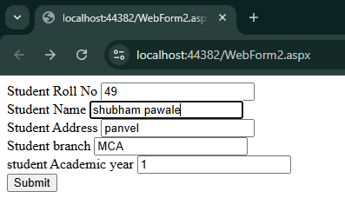

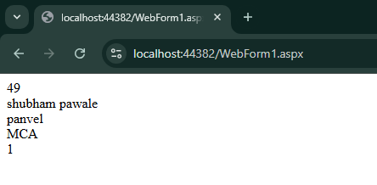

Practical 4

Webform1.aspx

<%@ Page Language="C#" AutoEventWireup="true" CodeBehind="WebForm1.aspx.cs" Inherits="WebApplication4.WebForm1" %>

<!DOCTYPE html>

<html xmlns="<http://www.w3.org/1999/xhtml>">

<head runat="server">

    <title></title>

</head>

<body>

    <form id="form1" runat="server">

        <div>

            <asp:Label ID="Label1" runat="server" Text="Num1"></asp:Label><asp:TextBox ID="TextBox1" runat="server"></asp:TextBox><br />

            <asp:Label ID="Label2" runat="server" Text="Num2"></asp:Label><asp:TextBox ID="TextBox2" runat="server"></asp:TextBox><br />

            <asp:Label ID="Label3" runat="server" Text="Result"></asp:Label><asp:TextBox ID="TextBox3" runat="server"></asp:TextBox><br />

            <asp:Button ID="Button1" runat="server" Text="add" OnClick="Button1_Click" />&nbsp

            <asp:Button ID="Button2" runat="server" Text="sub" OnClick="Button2_Click" />&nbsp

            <asp:Button ID="Button3" runat="server" Text="mul" OnClick="Button3_Click" />&nbsp

            <asp:Button ID="Button4" runat="server" Text="div" OnClick="Button4_Click" />

        </div>

    </form>

</body>

</html>

**webform1.aspx.cs**

using System;

using System.Collections.Generic;

using System.Linq;

using System.Web;

using System.Web.UI;

using System.Web.UI.WebControls;

namespace WebApplication4

{

    public partial class WebForm1 : [System.Web.UI.Page](http://system.web.ui.page)

    {

        protected void Page_Load(object sender, EventArgs e)

        {

        }

        protected void Button1_Click(object sender, EventArgs e)

        {

            int res= int.Parse(TextBox1.Text) + int.Parse(TextBox2.Text);

            TextBox3.Text = res.ToString();

        }

        protected void Button2_Click(object sender, EventArgs e)

        {

            int res = int.Parse(TextBox1.Text) - int.Parse(TextBox2.Text);

            TextBox3.Text = res.ToString();

        }

        protected void Button3_Click(object sender, EventArgs e)

        {

            int res = int.Parse(TextBox1.Text) * int.Parse(TextBox2.Text);

            TextBox3.Text = res.ToString();

        }

        protected void Button4_Click(object sender, EventArgs e)

        {

            double res = double.Parse(TextBox1.Text) / double.Parse(TextBox2.Text);

            TextBox3.Text = res.ToString();

        }

    }

}

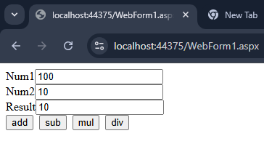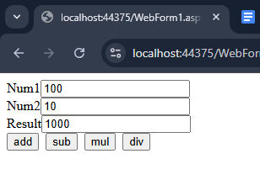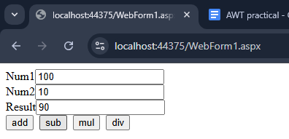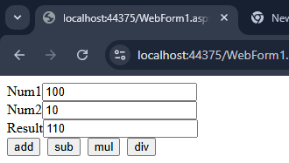

create a simple web page to show asp.net page life cycle